Washington: Symbol and City
Prof. Wiley

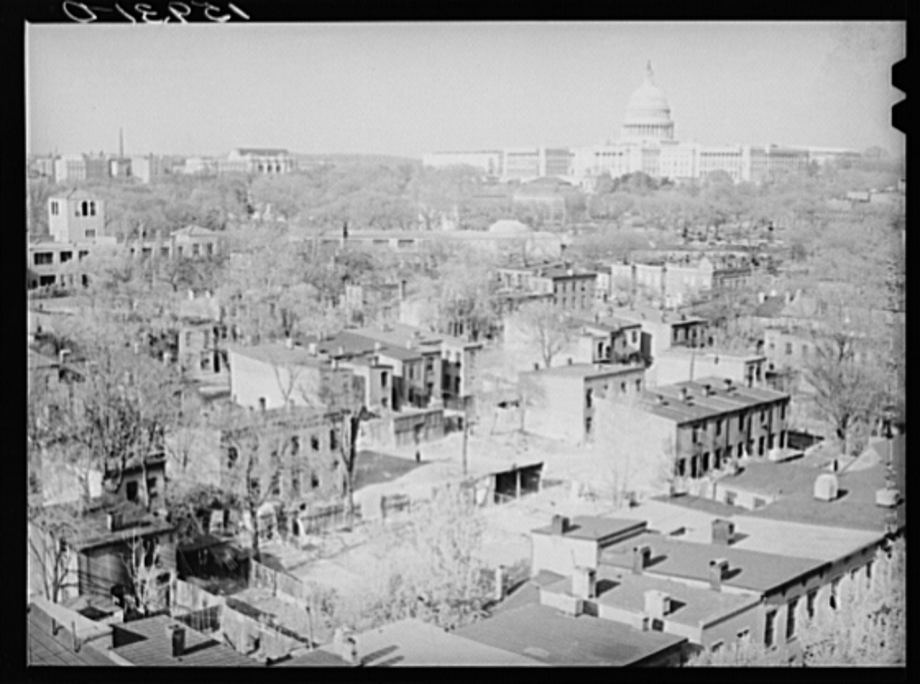
LOC: David Moffat Myers, Southwest DC 1939

“Washington is a city of Southern efficiency and Northern charm.”
John F. Kennedy

This graduate seminar is an examination of the relationship between the ideals of democratic urban life, ways that these ideals are physically and symbolically constructed, and the actualities of the embodied experience of those spaces. The central theme to this urban investigation is Washington: Symbol and City. The course explores such topics as: cultural geography of the early republic, urban planning for a new democracy, the effect of industrialization on the city, the waves of rural migration and overseas immigration that changed the social demographics of the city, the impact of the City Beautiful and urban renewal, monuments and the national memory, as well as historic preservation and gentrification.

The course is interdisciplinary in nature: our investigation into the city of Washington, D.C. will include methods and theory from anthropology, art history, architecture, geography, history, landscape studies, and planning. We will use both primary and secondary sources to gain an understanding of the city over time; the course readings will be coupled with representations of the city in various media – art, film, music, novels, and poetry. Students should be willing to complete the reading, think deeply about the themes covered, and come prepared to participate in class.

